**PIZZA SALES SQL QUERIES**

**A. KPI’s**

**1. Total Revenue:**

SELECT SUM(total_price) AS Total_Revenue FROM pizza_sales;

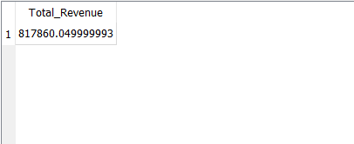

**2. Average Order Value**

SELECT (SUM(total_price) / COUNT(DISTINCT order_id)) AS Avg_order_Value FROM pizza_sales

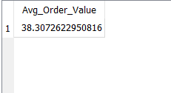

**3. Total Pizzas Sold**

SELECT SUM(quantity) AS Total_pizza_sold FROM pizza_sales

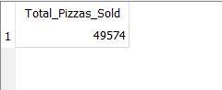

**4. Total Orders**

SELECT COUNT(DISTINCT order_id) AS Total_Orders FROM pizza_sales

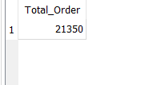

**5. Average Pizzas Per Order**

SELECT CAST(CAST(SUM(quantity) AS DECIMAL(10,2)) /

CAST(COUNT(DISTINCT order_id) AS DECIMAL(10,2)) AS DECIMAL(10,2))

AS Avg_Pizzas_per_order

FROM pizza_sales

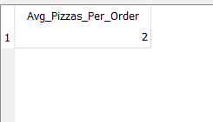

**B. Daily Trend for Total Orders**SELECT strftime ('%w', order_date) AS order_day_number,

CASE strftime ('%w', order_date)

WHEN '0' THEN 'Sunday'

WHEN '1' THEN 'Monday'

WHEN '2' THEN 'Tuesday'

WHEN '3' THEN 'Wednesday'

WHEN '4' THEN 'Thursday'

WHEN '5' THEN 'Friday'

WHEN '6' THEN 'Saturday'

END AS order_day,

COUNT(DISTINCT order_id) AS total_orders

FROM pizza_sales

GROUP BY order_day_number;

***Output:***

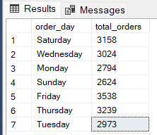

**C. Monthly Trend for Orders**

SELECT strftime('%m', order_date) AS Month , count(Distinct order_id)

FROM pizza_sales

GROUP BY strftime('%m', order_date)

***Output***

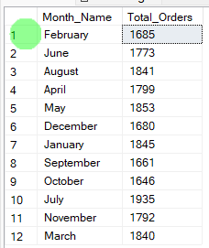

**D. % of Sales by Pizza Category**

SELECT

pizza_category, SUM (total_price) AS TotalSales, (SUM(total_price) / (SELECT SUM(total_price) FROM pizza_sales)) * 100 AS PercentageOfSales

FROM pizza_sales

GROUP BY pizza_category;

***Output***

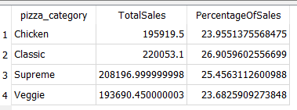

**E. % of Sales by Pizza Size**

SELECT

pizza_size, SUM(total_price) AS TotalSales,

CAST((SUM(total_price) / (SELECT SUM(total_price) FROM pizza_sales)) * 100 AS DECIMAL(10,2)) AS PercentageOfSales

FROM pizza_sales

GROUP BY pizza_size;

***Output***

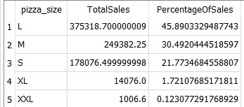

**F. Total Pizzas Sold by Pizza Category**

SELECT pizza_category,

SUM(quantity) AS TotalPizzasSold

FROM pizza_sales

GROUP BY pizza_category;

***Output***

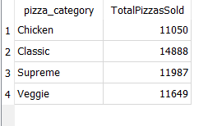

**G. Top 5 Pizzas by Revenue**

SELECT pizza_name, sum(total_price) As Total_Revenue FROM pizza_sales

GROUP By pizza_name

ORDER BY Total_Revenue DESC

LIMIT 5

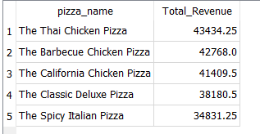

**H. Bottom 5 Pizzas by Revenue**

SELECT pizza_name, sum(total_price) As Total_Revenue FROM pizza_sales

GROUP By pizza_name

ORDER BY Total_Revenue ASC

LIMIT 5

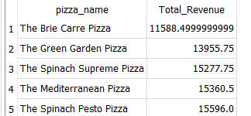

**I. Top 5 Pizzas by Quantity**

SELECT pizza_name, sum(quantity) As Total_Pizza_Sold FROM pizza_sales

GROUP By pizza_name

ORDER BY Total_Pizza_Sold DESC

LIMIT 5

***Output***

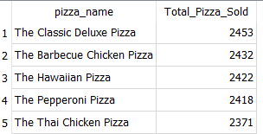

**J. Bottom 5 Pizzas by Quantity**

SELECT pizza_name, sum(quantity) As Total_Pizza_Sold FROM pizza_sales

GROUP By pizza_name

ORDER BY Total_Pizza_Sold ASC

LIMIT 5

***Output***

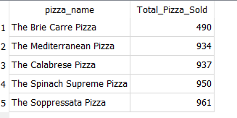

**K. Top 5 Pizzas by Total Orders**

SELECT pizza_name, count(DISTINCT order_id) As Total_Orders FROM pizza_sales

GROUP By pizza_name

ORDER BY Total_Orders DESC

LIMIT 5

**Output**

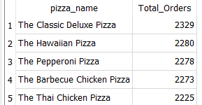

**L. Bottom 5 Pizzas by Total Orders**

SELECT pizza_name, count(DISTINCT order_id) As Total_Orders FROM pizza_sales

GROUP By pizza_name

ORDER BY Total_Orders ASC

LIMIT 5

**Output**

